| **The Coversheet** | |
| --- | --- |
| Student Name  (unless anonymised) | Pawan Agrahari |
| Student Number  (as shown on student ID card): | 230277162 |
| Word Count / Pages / Duration / Other Limits: | 4712 |
| Attempt Number: |  |
| Date of Submission: | 19/12/2024 |

|  |  |
| --- | --- |
| I have read and understood the [Academic Misconduct statement](https://blog.yorksj.ac.uk/assessment/coversheet-statements/). | Tick to confirm |
| I have read and understood the [Generative Artificial Intelligence use statement](https://blog.yorksj.ac.uk/assessment/coversheet-statements/). | Tick to confirm |
| I am satisfied that I have met the Learning Outcomes of this assignment  (please check the Assignment Brief if you are unsure) | **​​​** Met |

|  |
| --- |
| **Self-Assessment** – If there are particular aspects of your assignment on which you would like feedback, please indicate below.  Optional for students |
| ***Suggested prompt questions-***  *How have you developed or progressed your learning in this work?*  *What do you feel is the strongest part of this submission?*  *What feedback would you give yourself?*  *What part(s) of this assignment are you still unsure about?* |
|  |

**INTELLIGENT TUTORING SYSTEM**

**Table of Contents**

1. Introduction 4

2. Project Plan 4

3. Literature Review 5

4. Development of your Intelligent Tutoring System 7

4.1 Domain and Ontology Design 7

4.2 System Development and Integration 7

4.3 Development 8

4.4 User Interface 12

4.5 Limitations and Challenges 17

5. Conclusion 17

6. References 19

# 1. Introduction

The emergence of the educational technologies has made learners benefit from ITS which are intelligent tutoring systems that enables the development of adaptative learning modes. From a general perspective, ITS can be used in Physics to help students learn by providing each of them with instructions and feedback suited to student’s needs. In this work, and ITS is designed and implemented for Physics with the programming language Python, and the domain knowledge is described concerning Protege OWL. The objective of this ITS is to improve the performance of students through facilitating them in different areas of Physics including; mechanics, thermodynamics and electromagnetic through provision of feedbacks and tests. It should also follow each student’s individual learning process, explain the steps for solving particular problems, and offer recommendations. This will try to close the gap between conventional teaching and partage of teaching and learning/facilitation which has incorporated the use of current technologists, so that students can be well equipped to master the subject of Physics.

Intelligent tutoring systems ITS have emerged in the last few years as a vital instrument for improving learning experiences because of the abilities of ITS in delivering intelligent tutoring. Physics, one of the biggest challenges in academic learning, appears to accrue the most positive impact from ITS mostly because of the field’s complex principles ranging from mechanics, thermodynamics, electromagnetism among others. This project revolves around the creation of an ITS for Physics in which system development is in Python while the domain ontology is in Protege OWL. It is to develop an automated system that enables learners to navigate different topics in Physics and receive feedback by providing practice problems that will help the learners get acquainted with essential issues.

***Background Research***

In the past decades, the growth of educational technologies has led to the development of sophisticated ITS which has moderate human-like tutoring purposes for delivering adaptive instruction. Such systems use the everyday artificial intelligence technologies comprising of machine learning, natural language processing and the expert systems in delivering education content relevant to the specific learner. In Physics education, ITS is most helpful because of the manner in which a number of concepts are taught; abstract and frequently requiring procedural support, feedback as well as constant evaluation. Earlier research has shown that ITS facilitates enhanced students’ involvement and comprehension. For example, Cognitive Tutor and Open-Source Physics present the learners with mechanics and other topics in physics, which enables them make consequences and choices as per their learning goals (Al-Chalabi *et al.* 2021). Such systems require proper and strong knowledge representation like ontologies so that the system can easily access to the relevant knowledge stored in the domain. Moreover, the studies of knowledge representation via ontologies have disclosed that this approach makes it possible to introduce more semantically meaningful representations of a subject matter than the traditional forms, which are essential for highly semantic subjects such as Physics. Ontologies describe relations between different concepts in terms of theory, and, therefore, it may help in course and in learner-adaptive approach as well.

# 2. Project Plan

The ITS for Physics is designed for Ph.D. students in Physics and is arranged into the following most important phases of the project. The plan sees to it that some form of instrumental delivery occurs to present students with a prototype of the kind of learning experience in Physics to be expected.

***Phase 1: I. To understand to future activities of the organization (1 – 2 weeks)***

1. To conduct research on the organization, its history, products, objectives and strategies 2. To gather requirements for the design with specifications of the current and future functioning of the organization.

Defining learning scope and specify Physics topics for the ITS.

Source literature on related ITS for Physics and other related fields.

***Phase 2: Ontology Design (Week 3-4)***

In this assignment, you need to create a domain ontology through using of Protégé to express the various concepts within the domain of Physics.

Describe what one means by class, property and relationship between entities in a particular domain of interest.

***Phase 3: System Development (Week 5-8)***

Implement the ITS using Python for backend and integrate the ontology in this language.

Design elements for the dialogue and response between the user interface.

***Phase 4: In the final stage, Testing and Evaluation, is conducted in (weeks 9 and 10)***

That means to carry out both Unit Testing and User Acceptance Testing.

Such feedbacks will be collected to help fine-tune the proposed system.

***Phase 5: Documentation and Finalisation of the Project (Week 11 and 12)***

Issue the final report and present all the deliverables.

Ensure the system comes with a detailed write up on the type of features it has and how each works.

| **Phase** | **Tasks** | **Duration** |
| --- | --- | --- |
| Research and Requirement Gathering | Define scope, gather literature, identify topics | Week 1-2 |
| Ontology Design | Develop Protégé ontology, define Physics concepts | Week 3-4 |
| System Development | Implement Python code, integrate ontology, develop UI | Week 5-8 |
| Testing and Evaluation | Conduct testing, collect feedback, refine system | Week 9-10 |
| Documentation and Finalization | Write report, document system functionality, finalize project | Week 11-12 |

**Table 1: Project Plan**

# 3. Literature Review

***a. Introduction to ITS concept in Education***

Intelligent Tutoring Systems (ITS) are computer implemented systems whose underlining purpose is to teach learners. These systems also have a knowledge component which makes the work of the student easy, as useful tips are provided on areas of the subject that requires special focus, and the speed of learning is controlled. As per the view of Beygi Nasrabadi *et al.* 2024, when applied in Physics education more specifically, ITS will be useful in the sense that it provides the students with dynamic forms of problems solving exercises and explanation. ITS practices methodologies of artificial intelligence for example knowledge based, natural language processing, and machine learning in order to mimic tutor’s role in student’s learning process.

It’s are advanced paradigms of smarter education systems that could foster better student performance in terms of learning. It has been resembling a human tutor in terms of assessing the progress of a learner, determine what areas that learner has mastered or not mastered, as well as deliver recommendations and instruction based on a set of algorithms that are characteristic of artificial intelligence. In contrast to conventional approaches to learning, ITS learn about the student over time and offer lessons and practice activities that best fit. These systems work well in a number of areas such as Mathematics, Physics and Chemistry to name a few (AlHumoud *et al.* 2022). ITSs typically consist of several components: Knowledge component, which contains the courses necessary information; student model that contains learner’s information; engine, which computes student model and modifies the information necessary for the learner; and interface for communication. This is because by evaluating a student’s answers and communication style with the system, the ITS can deliver responsive advice, additional hints, and other perspectives. In Physics education more specifically, ITS can potentially deliver important advantages, specifically in allowing learners to try out concepts, solve problems, and receive immediate feedback on their knowledge (Law *et al.* 2020). This dynamic, and individualized approach helps learning and consequently optimizes the results of education.

***b. Selected ITS Models and Theories for the Teaching and Learning of Physics***

Several ITS have been designed and implemented to support teaching and learning of Physics and while the approach to designing and implementing them differ, most of the ITS serve the following functions. There are simple systems that cover only one area of physics – mechanics, electromagnetism etc, while there are systems that cover the whole syllabus.

Physics Educational Systems: Some examples of systems are “Cognitive Tutor” by Carnegie Learning and “Open-Source Physics” employing the strategy majoring on problem-solving skills as well as content knowledge (Calegari *et al.* 2021). These platforms employ algorithms in tracking the performance of the students and then give feedback based on the activity completed by the students.

Learning Styles and Adaptivity: In another way, ITS possess the flexibility because they manage to trump various types of learners. Tools like ‘STELLA’ offers features of adaptive learning which allows different students to learn with the use of visuals, those who learn better when they act out are well catered for as the system provides simulations on the content being presented (Chen *et al.* 2023). This kind of adaptivity is especially important in Physics where teaching involves the explanation of numerous abstract and intricate physical events in which visual and practical approaches may be extremely helpful.

***c. Ontology and KR in ITS***

Thus, it becomes clear that the problem of knowledge representation plays an important role in achieving success in ITS for Physics. Ontologies are employed with the purpose of describing formally the concepts, the rules and relationships that are related to the domain of Physics. They offer a structure through which the system may reason about the content and engage with it in a manner that enables the provision of relevant ITS feedback.

Protégé as a Tool: Protégé is used for ontologies creation and it offers graphical view to define domain knowledge in the sense of classes, properties and relationships. This approach enables semantic reasoning and makes it possible to adapt the instruction provided to the learner depending on the same learner (Franzén *et al.* 2024). Ontology in Physics could name objects like “Force”, “Velocity” or “Energy”, and connections between such items as Newton’s second law that connects force and acceleration.

Limitations and Challenges: However, as with any type of ontologies, it lacks the flexibility to accommodate all the real physical problems as seen in Physics. Often, that do not map well to higher level problems such as multi-variable problem or abstract concepts where the framework of a simple ontology may not suffice. In addition, there is a question to using expert knowledge for defining the ontology – it may not be very flexible.

***d. Execution of ideas and their reception from users***

This paper acknowledges that the major aspect to any ITS is user interaction and feedback. For a Physics ITS, the system should not only give explanation but at the same time present solutions in a step-by-step procedure.

Step-by-Step Guidance: This is perhaps a good idea as systems such as “ALEKS” have highlighted the necessity of taking an approach of ‘breaking down’ problems into solvable units. It assists students to see how to do Physics problems step by step, like the use of Newton formulas, or circuit calculations (Halford *et al.* 2023). All these make it easy to provide a step-by-step guidance because it reduces the chances of learners getting overwhelmed in the process of learning.

Instant Feedback: One of the features of ITS is the possibility of giving feedback instantly. In Physics this may involve mirroring a face-to-face class scenario where a student has presented his/her work/solution to a problem, identify errors and omissions and offer tips or other ways of arriving at a solution. It tends to encourage updated student performance feedback since they are corrected instantly without having to wait for another set of questions to be marked.

***e. Ontologies have a critical role to play in the development of system and application of Its***

Application of a well-developed ontology is vital in development of ITS since it gives structure to the domain knowledge. Ontologies are very useful in Physics since the subject might contain abstract ideas and the correlation of one idea might depend on another idea; such relationships are easily explained with the help of ontologies, e.g., “Force” and “Mass” and “Velocity.” Ontology engineering enables ITS to solve problems, describe behavioural aspects of physical systems and provide feedback to learners. The web ontology development tool known as Protégé enables educators and developers to develop complex ontologies based on classes, properties, and relationships that define the knowledge domain (Michalowski *et al.* 2021). That is why in Physics, an ontology could be Newton laws or laws of thermodynamics which should aid in automated reasoning by the ITS. This information is stored in an OWL (Web Ontology Language) file provided by Protégé, which can be accessed by the ITS to guide a student through problems.

***f. A review of the Adaptive Learning Models in ITS***

Another aspect that can be distinguished for ITSs is its capability to promote learners’ adaptations. Due to this flexibility, the system offers differentiated instruction based on the knowledge that student has gained, the rate they grasp concepts and even mistakes they make. Teaching in Physics entails varying the level of difficulty in the type of problems offered or switching between the kind of explanations offered depending on the performance of the learner. Learning Analytics and Performance Assessment: A majority of ITS apply learning analytics to monitor student progress in real time and adapt content delivery. This way if, for instance, a student tends to give related wrong answers the system may provide hints or an alternative explanation. For example, if the student gives wrong answers on application of Newton’s laws on a problem, the system can immediately give exercises on the particular topic, thus repeating the lessons and avoid misconceptions (Milosz *et al.* 2024). Machine Learning for Personalization: Analysing performance of advanced ITSs, some of the ITS have started adopting machine learning algorithms to enhance the flexibility of the ITS system.

# 4. Development of your Intelligent Tutoring System

## 4.1 Domain and Ontology Design

The first concept in designing the Physics ITS is to identify the body of knowledge for the activity. This system shall be under categories for example mechanics (motion force energy and the likes) and thermodynamics. As in most cases, by employing Protégé we will develop an ontology of these subjects, and will assign classes for the main topics, and properties for the connections between the topics. The domain and ontology used for the Physics ITS are centered on important ideas originating from classes such as mechanics, thermodynamics and electromagnetism. These are represented by classes, relationships between the classes are defined by the properties of the classes, for instance, force class in related with acceleration class through newton’s second law class. The proposed ontology also contains problem-solving rules so that the system can provide relevant advice. This knowledge representation provides the ITS with the information needed to reason about student queries, enable effective adaptation of learning types, and facilitate problem-solving processes.

## 4.2 System Development and Integration

The ITS will be created in Python, with application of GUI library Tkinter; OWL API will be used to interface with the Protégé ontology. The system shall have the features of displaying Physics problems to the user, take an input from the user and output an analysis of the input based on the rules set in the ontology. For instance, if a student calculates the wrong value for acceleration is a Newton’s law problem, the system will highlight this as an error and will show the right way to continue the computation (Horsch *et al.* 2021). ITS system development with Python at the back end and incorporation of the ontology developed with Protégé. For the user interface (UI) Tkinter, which is a Python library is deployed permitting the students to handle the system through a GUI. The system interacts with the ontology using the OWL API which allows the dynamic query of the domain knowledge and the reasoning of the result of student input. Their integration enables the ITS to give the student an immediate score and also vary the difficulty of problems and offer the learners precise directions and suggestions on how to go about Physics issues.

## 4.3 Development

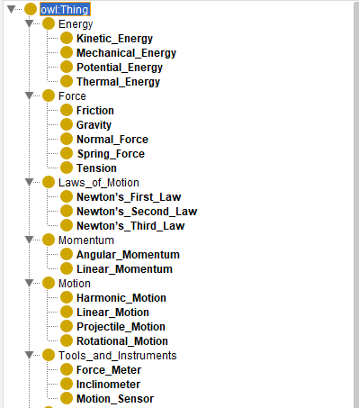

**Figure 1: Class Hierarchy of Classical Mechanics Ontology**

It illustrates the Class Hierarchy of the ontology. It begins with the root class owl:Thing, that is the most general of any ontology. Subcategories are Energy, Force, Laws_of_Motion, Momentum, Motion, Tools_and_Instruments. More subcategories appear under major classes, as for instance, under Force, comes Gravity, Friction, Normal_Force, and so on. It thus makes a logical presentation of major concepts in Classical Mechanics within a clear framework.

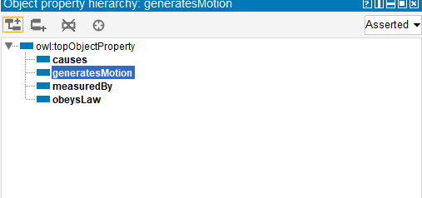

**Figure 2: Object Property Hierarchy**

The figure illustrates the Object Property Hierarchy concerning the relations between classes. It lists four key object properties: Causes, generates.Motion, Measured by, and obeys Law. Object properties are employed to specify a correlation between two or more classes, for example Force: generates or Tools: measures Motion (Ahmed and KOVÁCS, 2020). These relationships mean that the ontology can capture how concepts are related and dependent which is fundamental roles such as reasoning and querying.

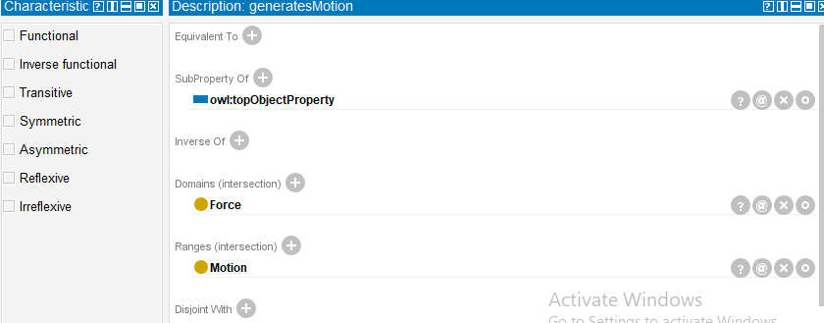

**Figure 3: Description of the Object Property ‘generatesMotion’**

This figure illustrates the field generating a motion of the object property of the generatesMotion. The Domain is defined as Force and the Range is defined as Motion. This kind of property is a representation of a force – like gravity or tension- producing a sort of movement –like linear or projectile motion. The figure also haves attributes such as Functional or Inverse, which are also further described.

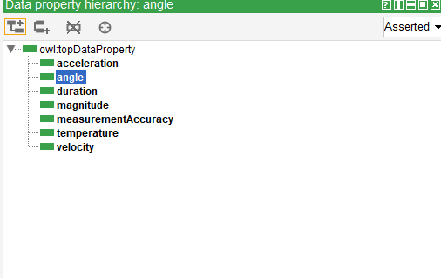

**Figure 4: Data Property Hierarchy**

It illustrates the Data Property Hierarchy of the designed ontology. Data properties link an instance of a class to a value or a literal or number value for example. The hierarchy is indicated below: acceleration, angle, duration, magnitude, measurementAccuracy, temperature, velocity (Alshboul *et al.* 2021). These data properties make it possible to provide quantitative characterization of classes such as Motion (e.g., velocity = 3 m/s) or Tools_and_Instruments (e.g., measurementAccuracy = high).

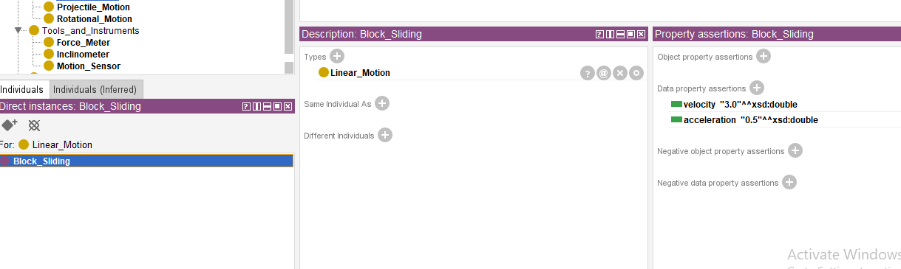

**Figure 5: Individual Instance ‘Block_Sliding’**

The figure indicates one instance type called Block_Sliding within the class Linear_Motion. In the description pane, it mentions its data property assertions: velocity is assigned 3.0 in m/s; acceleration is set to be 0.5 in m/s². This captures how particular realistic examples-instances-are represented using the ontology through class inclusions as well as related data properties. This makes an ontology even more useful when applied in actual use scenarios like solving problems.

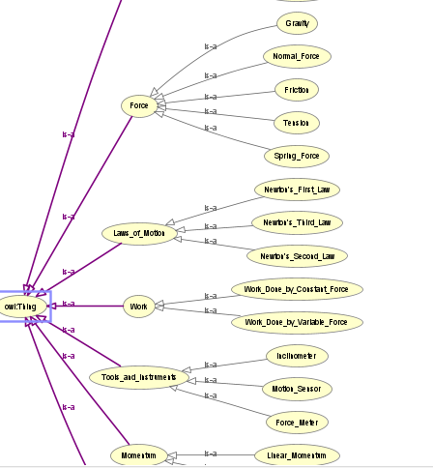

**Figure 6: Visual Graph of Ontology Relationships**

The figure gives a Visual Representation of the relationships in the ontology. The root class is owl:Thing, with each branch leading off to major classes such as Force, Laws_of_Motion, Work, Momentum, and Tools_and_Instruments. Each hierarchy has subclasses of Gravity, Tension, Newton's_Laws, and Work_Done_by_Constant_Force, depicted using arrows to illustrate relations (is-a), visualizing how the structure is dependent.

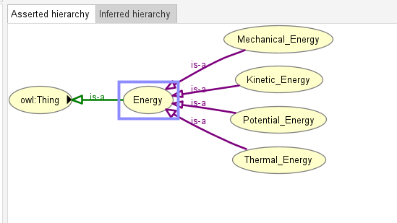

**Figure 7: Energy Subclass Hierarchy**

The figure is zoomed to show Energy Class Hierarchy in the physics ontology. The class Energy is linked to its four subclasses: The four fundamental forms of energy are Mechanical_Energy Kinetic_Energy, Potential_Energy and Thermal_Energy. Each subclass corresponds to certain form of energy in Classical Mechanics. From the parent Energy class and hence the ontology is able to capture the differences as well and similarities between different energy types.

## 4.4 User Interface

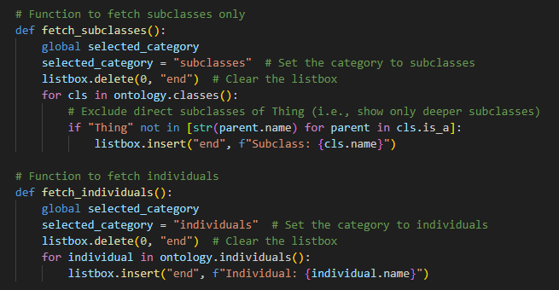

**Figure 8: Function to Fetch Subclasses and Individuals**

This figure represents the Python functions fetch_subclasses and fetch_individuals. Fetching subclasses function eliminates the direct subclasses of Thing and therefore only shows the deeper subclasses. In like manner, fetch_individuals retrieves all individuals within the ontology and places them in the interface (Chang *et al.* 2020). These functions clear the listbox and fill it dynamically with items belonging to the needed group and are sorted to allow clarity for the user.

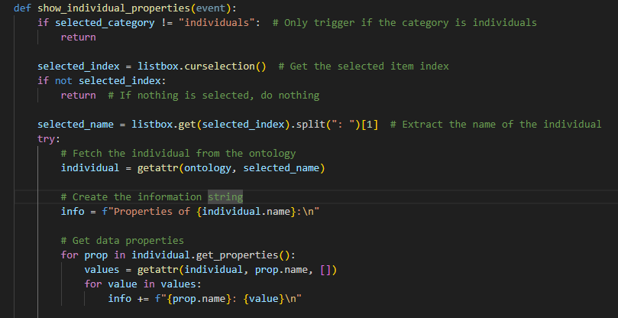

**Figure 9: Function to Display Individual Properties**

The figure depicts the function show_individual_properties, which is called upon an individual selection. This function fetches the name of the selected individual, retrieves it from the ontology, and then shows the properties. The function iterates through all data properties of the individual, formatting them for outputting purposes.

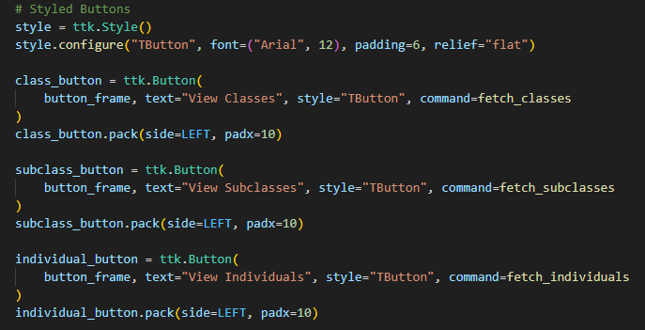

**Figure 10: Styled Buttons for User Interaction**

The figure shows that, for the interface widget, styled buttons are defined with ttk.Style. These buttons are ‘View Classes’, ‘View Subclasses’ and ‘View Individuals,’ where the texts are accompanied with font, padding and flat relief for a modern appearance. Each button has a function call which corresponds to the ontology data call for presentation and easy usage by users.

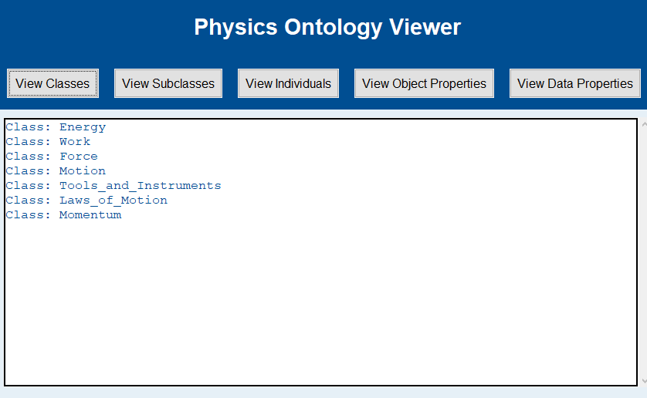

**Figure 11: Display of Top-Level Classes**

The figure below shows the output of the “View Classes” button. Top level classes which are displayed by list box are Energy, Work, Force, Motion, Tools_and_Instruments, Laws_Of_Motion and Momentum. These classes are actually the main categories of the Ontario, while the hierarchy of the classes enables the users to follow the structure of the knowledge model.

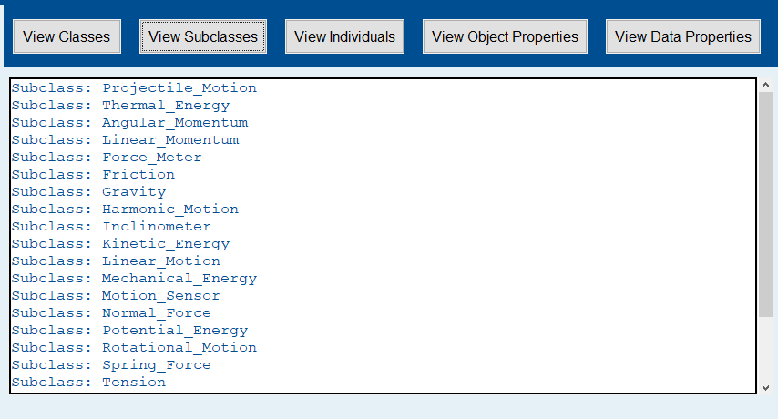

**Figure 12: Display of Subclasses**

This shows the result of the "View Subclasses" button. There are subclasses that appear such as Projectile_Motion, Thermal_Energy, Angular_Momentum, etc. They do not show direct subclass of Thing in order for deeper levels of the ontology to appear. It means that this also shows what is under other bigger categories and concepts, for instance, motion, energy, forces.

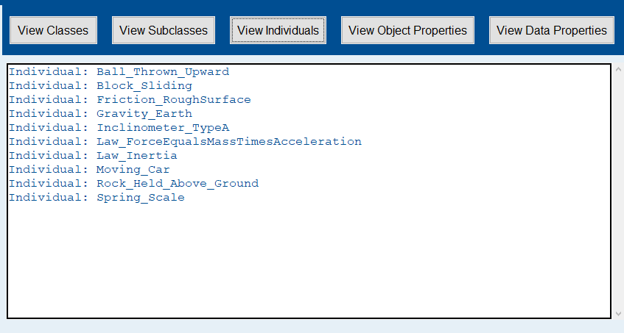

**Figure 13: Display of Individuals**

The figure shows the result of the "View Individuals" button. The examples include Ball_Thrown_Upward, Block_Sliding, Gravity_Earth, and Spring_Scale (Auna *et al.* 2024). These are concrete examples representing instances of ontology classes and give the users real-world data points in learning. The list is quite apparent to enable the users to engage with and analyze the individual entities.

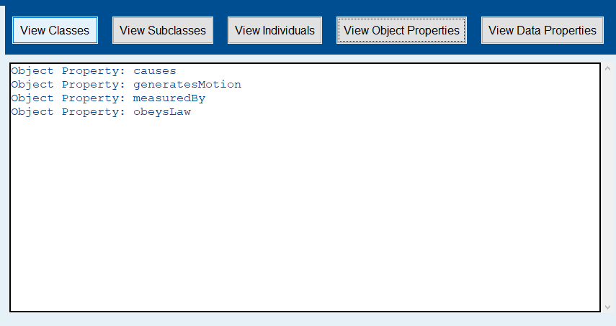

**Figure 14: Display of Object Properties**

This results from the "View Object Properties" button. Other properties for an object are: causes, generatesMotion, measuredBy, and obeysLaw. These describe relations of classes within the ontology-for instance, forces that generate motion or instruments that measure motion. Such relations add greater expressiveness to the ontology.

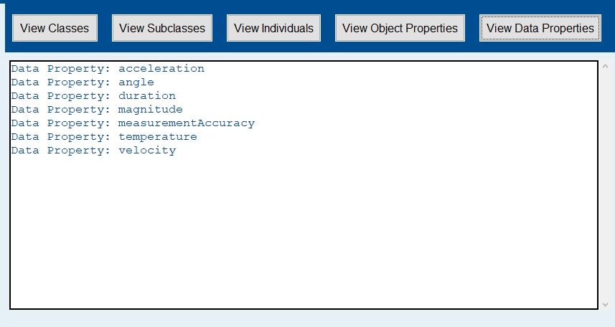

**Figure 15: Display of Data Properties**

The figure shows the "View Data Properties" output. The data properties mentioned are acceleration, angle, duration, magnitude, and velocity. These properties are representations of attributes of classes or individuals example, the velocity of an object or the angle of a motion. They're crucial in describing quantitative aspects of ontology.

## 4.5 Limitations and Challenges

The prototype though will be able to respond to certain topics at a minimum, it will lack the feature of responsiveness comprehensiveness of the topics to be covered and the depth of response provided. The latter is likely to vary in function of the naturae of the ontology and the problem-solving techniques of the system in question (Hu *et al.* 2022). This ITS will be an educational version aiding students in solving problems in Physics by simplifying problem solving processes and offering direct feedback. Nevertheless, the future enhancements of the system would benefit from improving on the algorithm incorporated by applying better machine learning and increasing the range of topics to encompass other advanced topics.

# 5. Conclusion

In conclusion, ITS for Physics, using developments from both Python and Protégé OWL, presents a feasible solution for improving the educational learning mechanisms in the context of the Physics discipline. This work shows how the use of ontology-based knowledge representation in conjunction with the principles of adaptive tutoring within a system can help improve learning and make it more student-centered and dynamic. The prototype that has been created is of basic subjects including mechanics and thermodynamics to the level that students can solve problems and receive immediate feedback as well as explanatory steps when necessary. The literature review identified the ITS features that needed to be integrated into the ITS research area to provide effective learning tactic, these include the existence of a domain-specific ontology, learning models that can adapt within the learning process and effective feedback to learners. All these aspects were incorporated into the process of ITS creation bringing the possibility to modify it based on the learner’s progress.

Although the current ITS prototype can be used to show the possibility of utilizing the AI tutoring systems, several shortcomings are apparent, especially with regard to scalability and depth of knowledge problem-solving. To cover a broad range of topics and refine feedback procedures, additional development would be needed, as well as to introduce more sophisticated learning methods, including the ML-based assessment of students’ activity in real-time mode.

To sum up, the project has revealed important aspects of design and realization of an ITS for-teaching Physics. It also plays an effervescent role of a teaching aid, which not only enables the student understand concepts the subject Physics, but also assists the student in learning effectively in personalized and more autonomous fashion. Further enhancements can be made to this ITS to make it stronger and elicit more better understanding of the subject Physics.

# 

# 6. References

Ahmed, G.H.A. and KOVÁCS, L., 2020. Ontology domain model for e-tutoring system. Journal OF Software Engineering & Intelligent Systems.

Al-Chalabi, H.K.M. and Apoki, U.C., 2021. A Semantic Approach to Multi-parameter Personalisation of E-Learning Systems. In *Modelling and Development of Intelligent Systems: 7th International Conference, MDIS 2020, Sibiu, Romania, October 22–24, 2020, Revised Selected Papers 7* (pp. 381-393). Springer International Publishing.

AlHumoud, S., Diab, A., AlDukhai, D., AlShalhoub, A., AlAbdullatif, R., AlQahtany, D., AlAlyani, M. and Bin-Aqeel, F., 2022, May. Rahhal: A tourist arabic chatbot. In *2022 2nd International Conference of Smart Systems and Emerging Technologies (SMARTTECH)* (pp. 66-73). IEEE.

Alshboul, J., Ghanim, H.A.A. and Baksa-Varga, E., 2021. Semantic Modeling For Learning Materials In E-Tutor Systems. J. Softw. Eng. Intell. Syst, 6(2), pp.17-24.

Auna, H.S., Prasetya, N.I., Surur, A.M., Ulfa, S., Soepriyanto, Y. and Salleh, S.M., 2024. Ontology Design Of A Modern Learning Environment And Modern Pedagogy Using Protégé Software. Indonesian Journal of Multidisciplinary Educational Research, 2(1).

Beygi Nasrabadi, H., Norouzi, E., Sack, H. and Skrotzki, B., 2024. Performance Evaluation of Upper‐Level Ontologies in Developing Materials Science Ontologies and Knowledge Graphs. *Advanced Engineering Materials*, p.2401534.

Calegari, R., Ciatto, G., Mascardi, V. and Omicini, A., 2021. Logic-based technologies for multi-agent systems: a systematic literature review. *Autonomous Agents and Multi-Agent Systems*, *35*(1), p.1.

Chang, M., D’Aniello, G., Gaeta, M., Orciuoli, F., Sampson, D. and Simonelli, C., 2020. Building ontology-driven tutoring models for intelligent tutoring systems using data mining. IEEE Access, 8, pp.48151-48162.

Chen, L.K., Gillan, J., Decker, M., Eteffa, E., Marzan, A., Thai, J. and Jewett, S., 2023. Embedding Digital Data Storytelling in Introductory Data Science Course: An Inter-Institutional Transdisciplinary Pilot Study. *Journal of Problem Based Learning in Higher Education*, *11*(2), pp.126-152.

Franzén, L.K., Lovaco, J. and Villas, F., 2024. SOTA Holistic SoS Engineering. *Delft University of Technology (TUD)*, *23*, p.01.

Halford, A.J., Bard, C.M., Burrell, A.G., McGranaghan, R.M., Wilson III, L.B., Jones Jr, M., Dong, C., Wang, L., Pulkkinen, T.I., Turner, N. and Liemohn, M.W., 2023. The importance of recruitment and retention in Heliophysics: it’s not just a pipeline problem. *Frontiers in Astronomy and Space Sciences*, *10*, p.1216449.

Horsch, M.T., Chiacchiera, S., Cavalcanti, W.L. and Schembera, B., 2021. *Data Technology in Materials Modelling* (p. 92). Springer Nature.

Hu, X., Lenz-Himmer, M.O. and Baldauf, C., 2022. Better force fields start with better data: A data set of cation dipeptide interactions. *Scientific Data*, *9*(1), p.327.

Law, E., Lee, K.J. and Ravari, P.B., 2020. The Curiosity Notebook: A Platform for SupportingLearning with Teachable Robots. In *HRI 2020 Workshop on Exploring Creative Contents in Social Robots*.

Michalowski, M., Wilk, S., Michalowski, W., O’sullivan, D., Bonaccio, S., Parimbelli, E., Carrier, M., Le Gal, G., Kingwell, S. and Peleg, M., 2021. A health eLearning ontology and procedural reasoning approach for developing personalized courses to teach patients about their medical condition and treatment. *International journal of environmental research and public health*, *18*(14), p.7355.

Milosz, M., Nazyrova, A., Mukanova, A., Bekmanova, G., Kuzin, D. and Aimicheva, G., 2024. Ontological approach for competency-based curriculum analysis. *Heliyon*, *10*(7).